# ASSIGNMENT # 1

**Computer Organization and Assembly Language**

***Note: Attempt all Questions by making code and output***

MUHAMMAD HASSAM KHAN

SID: 11141

# Question 01:

Using only basic arithmetic instructions, translate the given statement into assembly Language code.

Assume A, B and C are word variables A = B + 2 – (C*2)

**ANSWER 1: CODE:**

Include Irvine32.inc

.data

a byte "enter value b:",0 b byte "enter value c:",0 num1 dword ?

num2 dword ? num dword 2

.code main PROC

mov edx, OFFSET a call WriteString call ReadInt

mov num1,eax

mov edx, OFFSET B call WriteString call ReadInt

mov num2,eax

mov eax,num1 add eax,num

mov eax,num2 mov ebx,num mul ebx

sub eax,ebx

call writedec call crlf

exit

main ENDP END main

**SCREENSHOTS:**

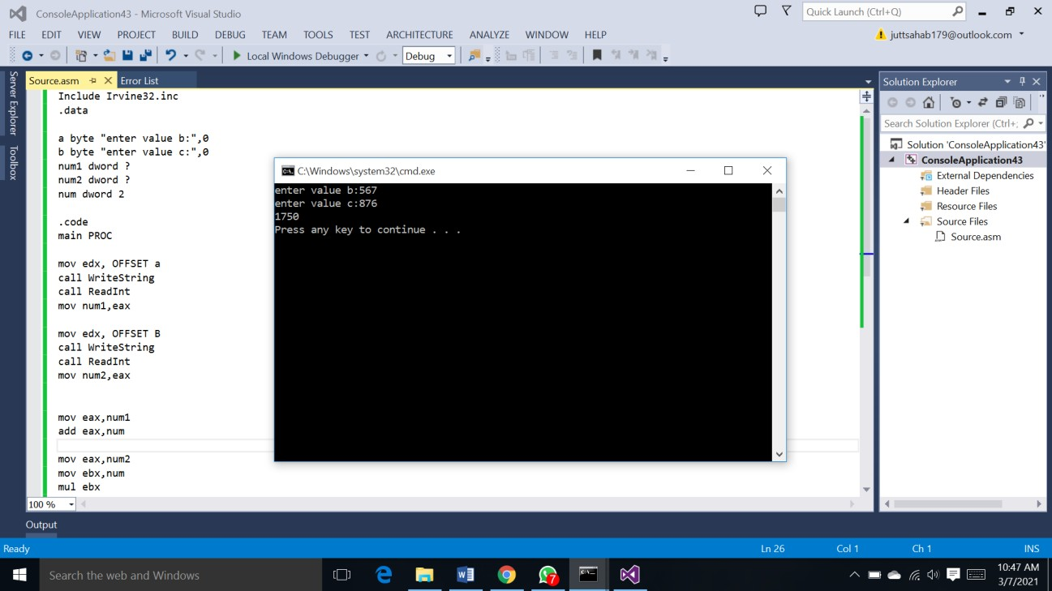

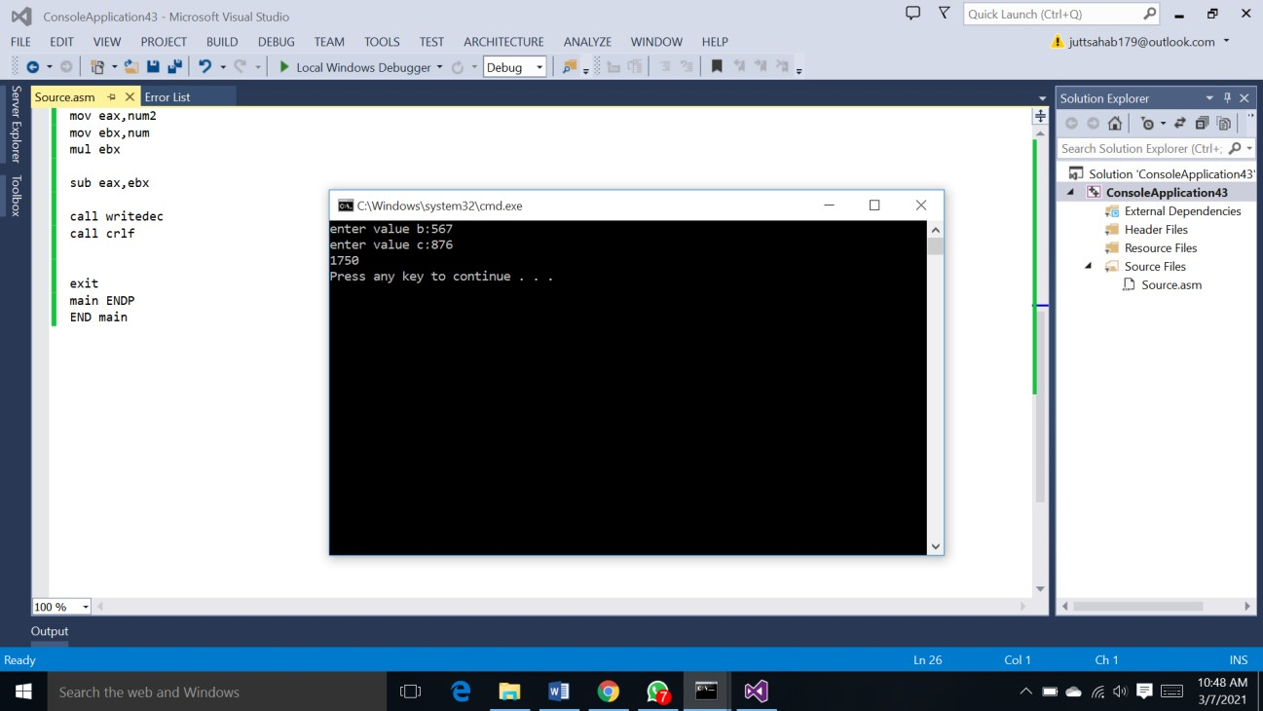

**Question 02:**

Write a program that displays the smallest and largest of five variables. The five variables are num1, num2, num3,num4 and num5 and are taken from user input.

**ANSWER 2:**

**CODE:**

; Q2

INCLUDE Irvine32.inc

.data

a1 byte "enter 1st number",0 a2 byte "enter 2nd number",0 a3 byte "enter 3rd number",0 a4 byte "enter 4th number",0 a5 byte "enter 5th number",0

num1 dword ? num2 dword ? num3 dword ? num4 dword ? num5 dword ?

largest DWORD ? smallest DWORD ?

.code main PROC

mov edx,offset a1 call WriteString call ReadInt

mov num1,eax

mov edx,offset a2 call WriteString call ReadInt

mov num2,eax

mov edx,offset a3 call WriteString call ReadInt

mov num3,eax

mov edx,offset a4 call WriteString call ReadInt

mov num4,eax

mov edx,offset a5 call WriteString call ReadInt

mov num5,eax

mov eax,num1 mov largest,eax cmp eax,num2 jge l1

mov eax,num2 mov largest,eax l1:

mov eax,largest cmp eax,num3 jge l2

mov eax,num3 mov largest,eax l2:

mov eax,largest cmp eax,num4 jge l3

mov eax,num4 mov largest,eax l3:

mov eax,largest cmp eax,num5 jge l4

mov eax,num5 mov largest,eax l4:

call writedec call crlf

mov eax,num1

mov smallest,eax cmp eax,num2

jle l5

mov eax,num2

mov smallest,eax l5:

mov eax,largest cmp eax,num3 jle l6

mov eax,num3

mov smallest,eax l6:

mov eax,smallest cmp eax,num4

jle l7

mov eax,num4

mov smallest,eax l7:

mov eax,smallest cmp eax,num5

jle l8

mov eax,num5

mov smallest,eax l8:

call writedec call crlf

exit

main ENDP END main

## SCREENSHOT:

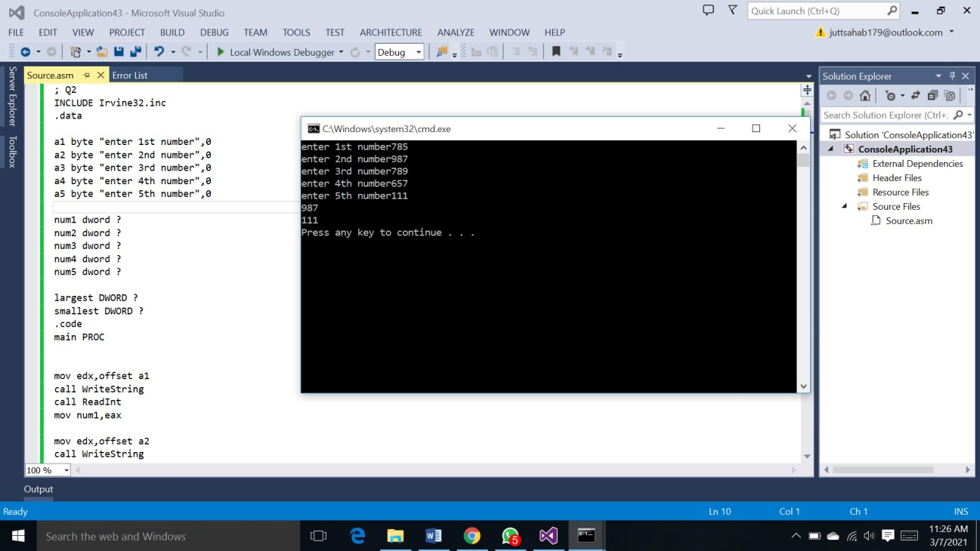

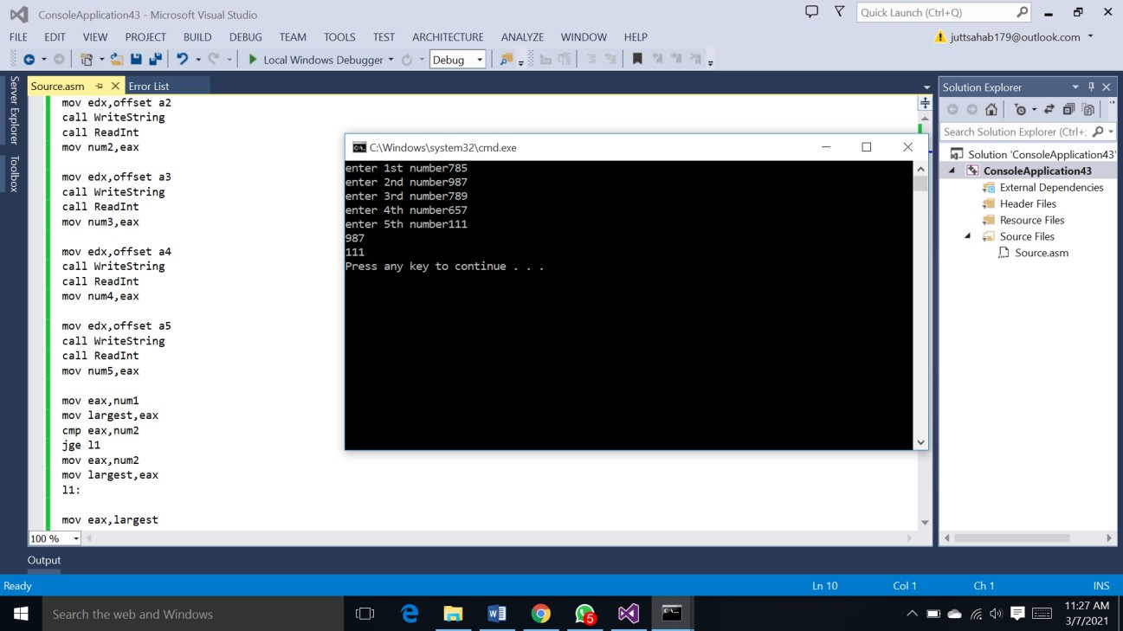

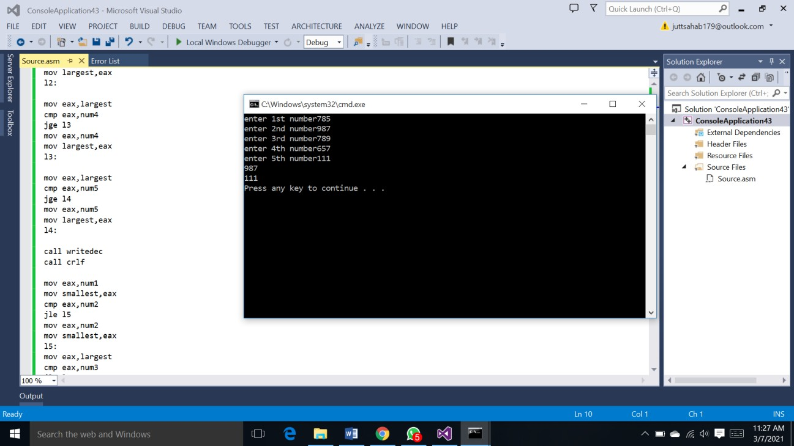

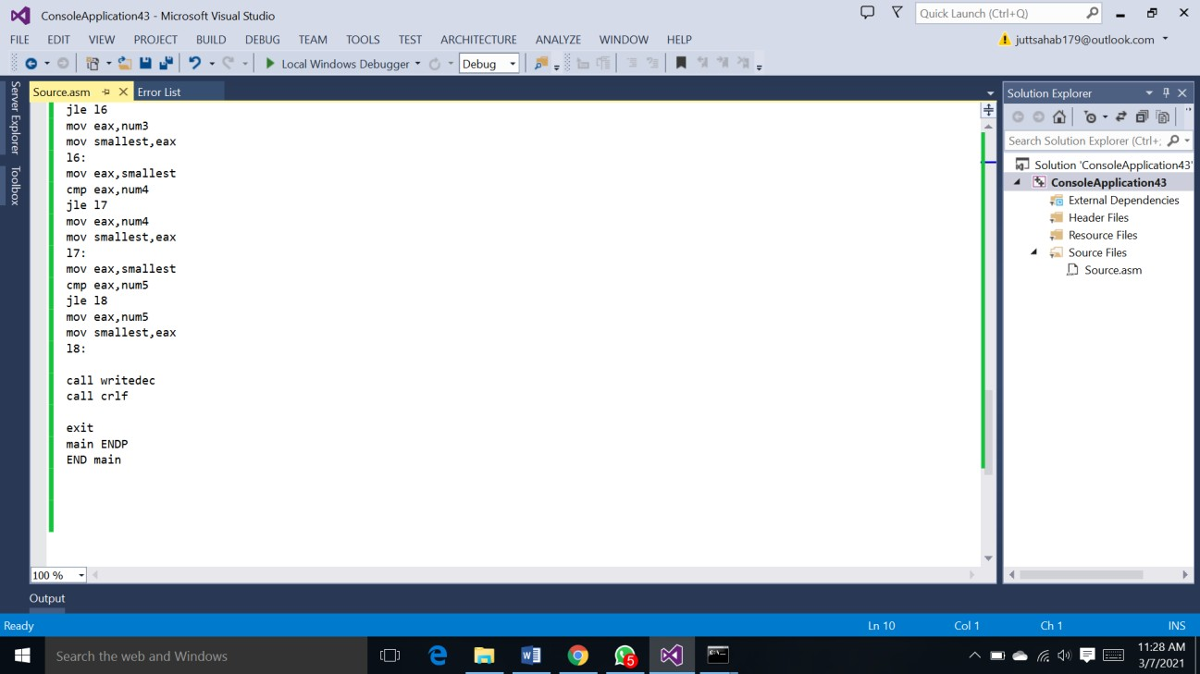

**Question 03:**

Perform the following INSTRUCTIONS on given values of registers and write FLAG values after execution.

|  |  |  |  |
| --- | --- | --- | --- |
| **AX/AL** | **BX/BL** | **INSTRUCTION** | **FLAG VALUE** |
| 02h | FFh | MUL BL | SF= 0 OF= 0 ZF= 0 |
| FFFFh | 02h | DIV BL | SF=0 OF=0 ZF= 0 |
| 3AD1h | AD2Bh | ADD AX,BX | SF=0 OF= 0 ZF= 0 |
|  |  |  |  |

**ANSWER 3:**

**MULTIPLY FLAG VALUE:**

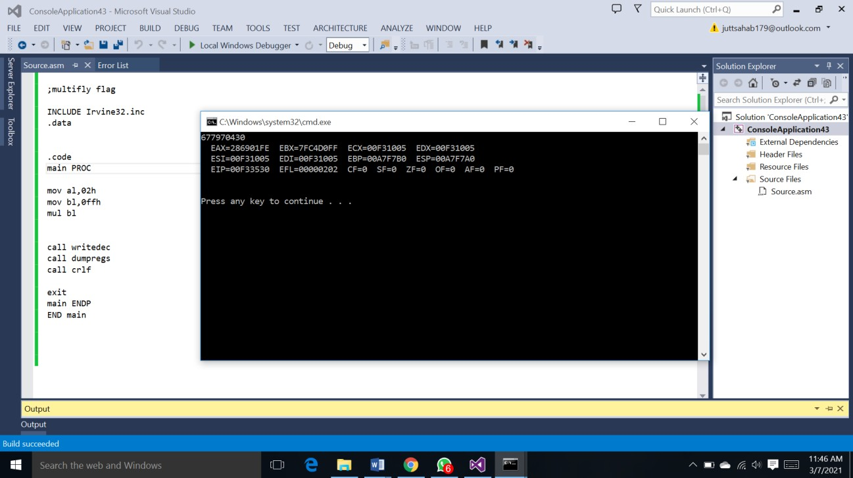

**DIVIDE FLAG VALUE:**

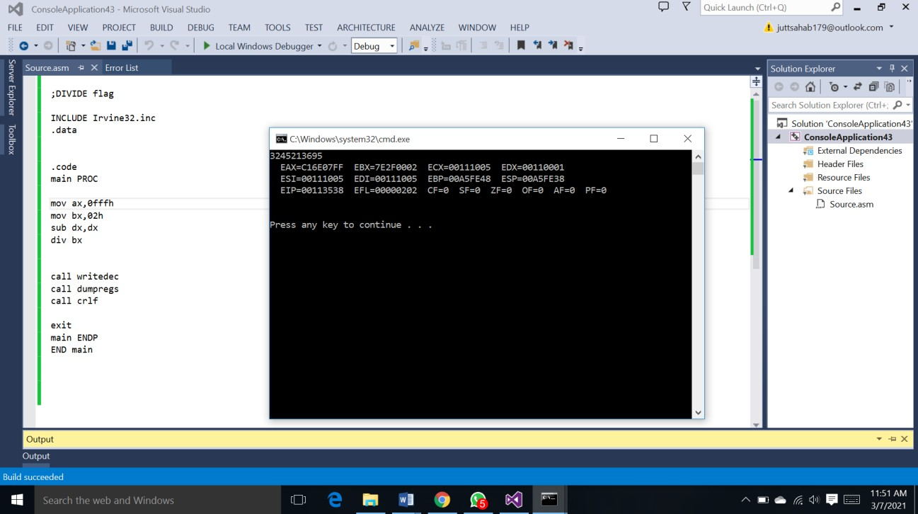

**ADD FLAG VALUE :**

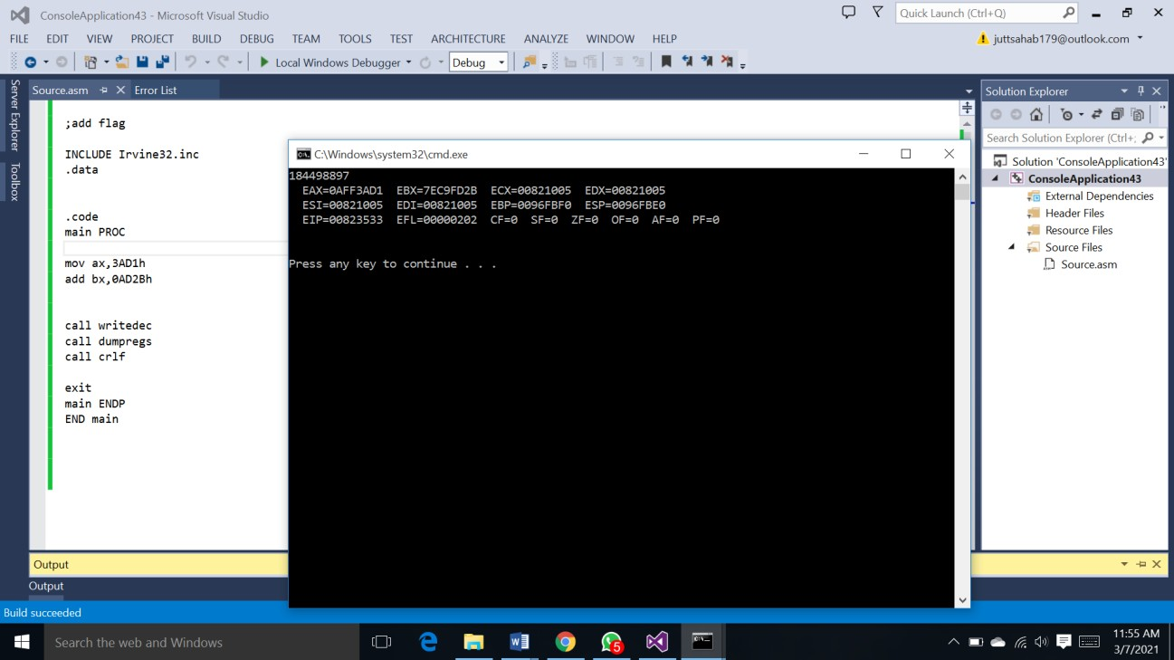

**Question 04:**

Convert below given statement into assembly language code:

IF ((X < Y) and (Z > T)) or (A <> B) THEN stmt1;

**ANSWER 4:**

**SCREENSHOT:**

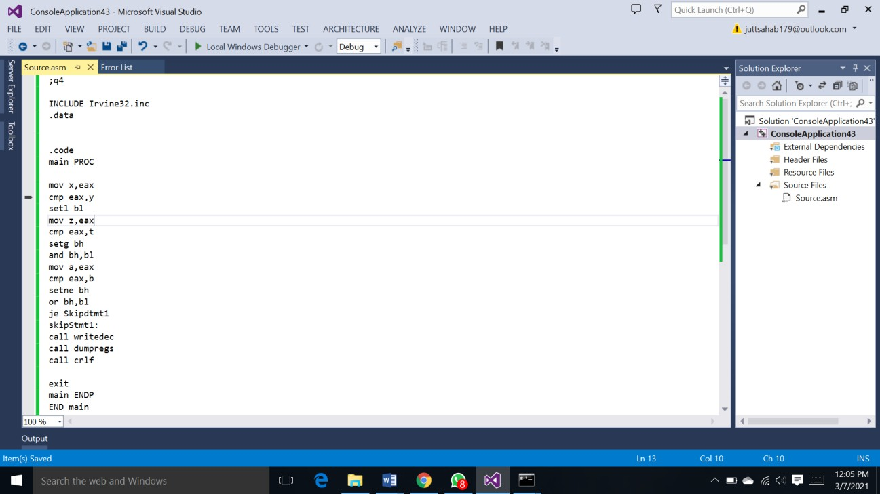

**Question 05:**

Make a program that prints a pyramid with ‘numbers’ and stearic “*” in the below given manner:

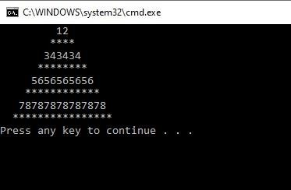

**CODE:**

;q5

INCLUDE Irvine32.inc

.data

star byte"**",0 lav1 dword 0,0

lav2 dword 0,0

lav3 dword 0,0

lav4 dword 0,0 space byte " ",0

.code main PROC mov ecx,1

.while ecx<=6 mov lav3,7

.while lav3>ecx

mov edx,offset space call writestring

dec lav3

.endw

mov lav1,1

.while lav1<=ecx mov eax,ecx

call writedec call writedec inc lav1

.endw call crlf

mov lav2,1 mov ebx,ecx add ebx,1 mov lav4,6

.while lav4>ecx

mov edx,offset space call writestring

dec lav4

.endw

.while lav2<=ebx mov edx,offset star call writestring inc lav2

.endw call crlf inc ecx

.endw

call waitmsg

exit

main ENDP END main

## SCREENSHOT:

